**1310 - lab 10**

**AVL (BALANCED) trees**

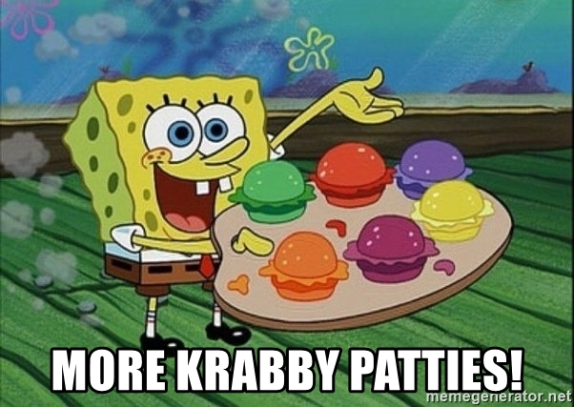

You are given a program which **organizes customers of the Krusty Krab according to customer name into a Binary Search Tree.** Each tree node contains a **customer’s name** and the **number of krabby patties they ate**. Modify this program so that the binary search tree is **always balanced using an AVL Tree**. You basically will be adding several private functions to the BinaryTree class.

I highly recommend you compile & run the given program (name the executable file KrustyKrab) using TEST_CASE.txt as input to see how it works before reading specifics on what you need to change.

## COMPILE GIVEN PROGRAM

**g++ -std=c++11 BinaryTree.cpp KrustyKrab.cpp –o KrustyKrab**

## RUN GIVEN PROGRAM

**KrustyKrab < TEST_CASE.txt**

# files that should be included in your submission

* BinaryTree.h
* BinaryTree.cpp
* KrustyKrab.cpp
* TEST_CASE.txt

# lab specifications (directions on how to write the program)

## Binary Tree Class

### **ADD the following functions to the BinaryTree class:**

* **balance**() – balance the tree into an avl tree
* **height**() – find the height of a BST node and return it from this function
* **diff**() – find difference between the height of the left & right subtrees of a given node and return it from this function
* Create a function for each possible rotation:
  + **r_rotation** – perform right rotation on a given parent node
  + **l_rotation** – performs left rotation on a given parent node
  + **lr_rotation** – performs left-right rotation on a given parent node
  + **rl_rotation** – performs right-left rotation on a given parent node
* **display**() – this function will display a HORIZONTAL view of the tree’s customer names (this must be a public function). Notice that it isn’t the full name – it is just the first two characters of the names.

The sample input below contains the BALANCED version of the BST.

Sq

Sp

Sh

Sa

Pe

ROOT-> Pa

Mr

Me

Ma

La

Ka

Ga

Fl

Eu

Di

Ba

If your tree is UNBALANCED, it will look like this:

Sq

ROOT-> Sp

Sh

Sa

Pe

Pa

Mr

Me

Ma

La

Ka

Ga

Fl

Eu

Di

Ba

### **MODIFY the following functions in the BinaryTree class:**

* **insert**() – the insert function should call the balance function

# Sample Output

_ _ ____ _ _ ___ _____ _ _ _ _ ____ _ ___

) |) / / _ \ ) () ( ( _( )__ __() () ( ) |) / / _ \ )_\ \ _)

| ( ( ) ' / | \/ | _) \ | | '. / | ( ( ) ' / /( )\ | (

)_|)_\ |_()_\ )____( )____) )_( /_( )_|)_\ |_()_\ )_/ \_(/__o)

Welcome to the Krusty Krab!

Choose one of the following options:

1. Enter customer data.

2. Display the Balanced BST horizontally.

3. Get statistics on Krabby Patties.

4. Search for a customer's data.

5. End Program.

ENTER 1-5: Enter a customer's name or -1 to quit entering data.

NAME: NUMBER KRABBY PATTIES EATEN:

Enter a customer's name or -1 to quit entering data.

NAME: NUMBER KRABBY PATTIES EATEN:

Enter a customer's name or -1 to quit entering data.

NAME: NUMBER KRABBY PATTIES EATEN:

Enter a customer's name or -1 to quit entering data.

NAME: NUMBER KRABBY PATTIES EATEN:

Enter a customer's name or -1 to quit entering data.

NAME: NUMBER KRABBY PATTIES EATEN:

Enter a customer's name or -1 to quit entering data.

NAME: NUMBER KRABBY PATTIES EATEN:

Enter a customer's name or -1 to quit entering data.

NAME: NUMBER KRABBY PATTIES EATEN:

Enter a customer's name or -1 to quit entering data.

NAME: NUMBER KRABBY PATTIES EATEN:

Enter a customer's name or -1 to quit entering data.

NAME: NUMBER KRABBY PATTIES EATEN:

Enter a customer's name or -1 to quit entering data.

NAME: NUMBER KRABBY PATTIES EATEN:

Enter a customer's name or -1 to quit entering data.

NAME: NUMBER KRABBY PATTIES EATEN:

Enter a customer's name or -1 to quit entering data.

NAME: NUMBER KRABBY PATTIES EATEN:

Enter a customer's name or -1 to quit entering data.

NAME: NUMBER KRABBY PATTIES EATEN:

Enter a customer's name or -1 to quit entering data.

NAME: NUMBER KRABBY PATTIES EATEN:

Enter a customer's name or -1 to quit entering data.

NAME: NUMBER KRABBY PATTIES EATEN:

Enter a customer's name or -1 to quit entering data.

NAME: NUMBER KRABBY PATTIES EATEN:

Enter a customer's name or -1 to quit entering data.

NAME:

Welcome to the Krusty Krab!

Choose one of the following options:

1. Enter customer data.

2. Display the Balanced BST horizontally.

3. Get statistics on Krabby Patties.

4. Search for a customer's data.

5. End Program.

ENTER 1-5:

Here is the Current BST in horizontal format:

Sq

Sp

Sh

Sa

Pe

ROOT-> Pa

Mr

Me

Ma

La

Ka

Ga

Fl

Eu

Di

Ba

Welcome to the Krusty Krab!

Choose one of the following options:

1. Enter customer data.

2. Display the Balanced BST horizontally.

3. Get statistics on Krabby Patties.

4. Search for a customer's data.

5. End Program.

ENTER 1-5:

LEAST NUMBER OF KRABBY PATTIES EATEN: Gary the Snail, 1 Krabby Patties

LARGEST NUMBER OF KRABBY PATTIES EATEN: SpongeBob Squarepants, 855 Krabby Patties

TOTAL NUMBER OF KRABBY PATTIES EATEN: 1348

Welcome to the Krusty Krab!

Choose one of the following options:

1. Enter customer data.

2. Display the Balanced BST horizontally.

3. Get statistics on Krabby Patties.

4. Search for a customer's data.

5. End Program.

ENTER 1-5:

Which customer are you looking for?

Barnacle Boy

Dirty Bubble

Eugene H. Krabs

Flying Dutchman

Gary the Snail

Karen Plankton

Larry the Lobster

Man Ray

Mermaid Man

Mrs. Puff

Patrick Star

Pearl Krabs

Sandy Cheeks

Sheldon J. Plankton

SpongeBob Squarepants

Squidward Tentacles

Enter the name of the customer.

NAME:

Sandy Cheeks ate 12 Krabby Patties

Welcome to the Krusty Krab!

Choose one of the following options:

1. Enter customer data.

2. Display the Balanced BST horizontally.

3. Get statistics on Krabby Patties.

4. Search for a customer's data.

5. End Program.

ENTER 1-5:

Which customer are you looking for?

Barnacle Boy

Dirty Bubble

Eugene H. Krabs

Flying Dutchman

Gary the Snail

Karen Plankton

Larry the Lobster

Man Ray

Mermaid Man

Mrs. Puff

Patrick Star

Pearl Krabs

Sandy Cheeks

Sheldon J. Plankton

SpongeBob Squarepants

Squidward Tentacles

Enter the name of the customer.

NAME:

Bob Ross is not a customer of the Krusty Krab.

Welcome to the Krusty Krab!

Choose one of the following options:

1. Enter customer data.

2. Display the Balanced BST horizontally.

3. Get statistics on Krabby Patties.

4. Search for a customer's data.

5. End Program.

ENTER 1-5:

Goodbye!